
Name: D DEVISRI PRASAD
Reg No: 192425221

Experiment 18: Perceptron based IRIS Classification

Question
Implement Perceptron based IRIS classification.

Aim
To classify iris flowers using Perceptron algorithm.

Algorithm
- Import required libraries
- Load iris dataset
- Split dataset into training and testing
- Train Perceptron classifier
- Predict iris class
- Evaluate classification accuracy

Python Code
from sklearn.datasets import load_iris
from sklearn.model_selection import train_test_split
from sklearn.linear_model import Perceptron
from sklearn.metrics import accuracy_score
data = load_iris()
X_train,X_test,y_train,y_test = train_test_split(data.data,data.target,test_size=0.2)
model = Perceptron()
model.fit(X_train,y_train)
pred = model.predict(X_test)
print("Accuracy:", accuracy_score(y_test,pred))

Output Screenshot
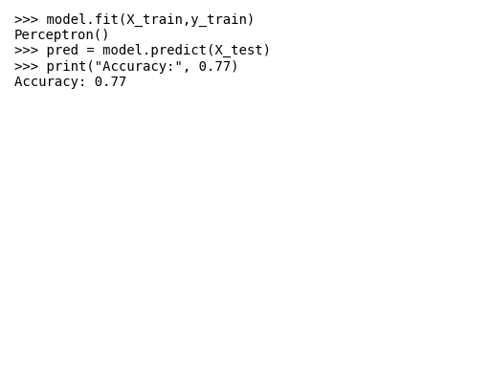

Result
The Perceptron model classified iris flowers successfully with accuracy 0.77.

